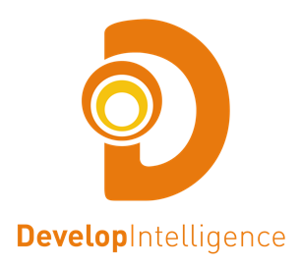

**Machine Learning: Algorithms & Applications**

**Course Overview:**

The **Machine Learning: Algorithms & Applications** course takes a deeper look at data analysis techniques and presents opportunities for students to practice with relevant data. This course builds on the **Machine Learning: Data Foundation** course and takes a deeper dive into Data Science, Data Driven and Visualization techniques. The course also introduces topics like data cleansing, performance and operationalizing analytics. Students will get more instruction about how Python can be used to analyze data so that they can apply techniques through exercises and hands-on labs. Throughout the course, students will explore a Salesforce Product dataset.

**Productivity Objectives:**

**After this course, you will be able to:**

* Describe advanced statistics technique to support Machine Learning analytics and conduct multiple tests for confidence.
* Leverage the Machine Learning Checklist and apply it to any data set.
* Describe the difference between good and bad data and implement data cleansing techniques.
* Improve the results of your data analysis by implementing dimensionality reduction.
* Explain multiple Machine Learning analysis techniques in detail and apply those techniques to your own data sets to develop qualitative intent.
* Apply Machine Learning analysis concepts to new projects in order to make better use of data.

**Course Duration:** This course will be delivered in 3 days.

**Course Outline:**

* Course Introduction
* Python Numerics
  + NumPy
  + Pandas
* Data Driven Deeper Dive
  + Mean and Median
  + T Tests
  + Z Scores
  + Confidence Intervals
  + Bias and Variance
* Data Science Deeper Dive
  + Machine Learning Checklist
* Data Cleansing
  + Field validation
  + Value validation
  + Time Series Data
  + Tools
* Performance
  + Industry Trends
  + GPUs
  + Cloud
  + Clusters
* Data Visualization
* Dimensionality Reduction
* Algorithm Selection
  + Linear Regression
  + Nearest Neighbors
  + Support Vector Machines
  + Bayesian Classifier
  + Decision Trees
* Operationalizing Models
  + Optimization
  + Deployment
  + Testing
  + Continuous Training
  + Model Updates